# CAPE WATCH

## User Manual

Contents

CAPE WATCH 1

User Manual 1

General Information 3

For the public: 3

For police officers: 3

Overall: 3

System Overview: 4

Organization of the Manual: 4

The user manual consists of three sections: 4

System Summary: 5

System Configuration: 5

User Access Levels: 5

Contingencies: 5

Getting started: 6

Home page: 6

Login Page 7

Profile Page: 9

Reports Page: 12

Statistics 13

Hotspots 13

Contact Us 14

# General Information

The Cape Watch system is a website which displays general crime statistics to the public of the greater Western Cape, as well as allows registered police officers to share investigation information over the website.

## For the public:

Cape Watch allows the public and guest users on the website to view crime statistics all over the greater Western Cape. A user will have the ability to scroll through the statistics website page which displays all crime information from the type of crimes occurring, the general time of crime occurring and a comparison between these related crimes.

Cape Watch purpose is to allow the public to become more knowledgeable and aware about all crime happening on a day –to – day basis. Being aware of all kind of crime related situations and predicaments will allow a user to be more caution with their whereabouts to ensure safety for themselves and loved ones.

## For police officers:

Police officers will be able to register on the Cape Watch website by supplying their personal and professional information. The purpose of this action is to allow police officers to share and respond to crime reports in an easy manner. There will be no hassle with paper documentation and therefore allowing all reports and documents to be saved in a constructive, organised and safe way.

Police officers will also be able to view all crime statistics and the relationships between the type of crimes, the time the crimes occurred and the areas in which it is occurring the most frequent. This information will allow police task forces to make decision on whether to do to more rounds in certain areas than others and help them to strategize on their techniques to stop crimes from happening as frequently as they are.

## Overall:

Crime cannot be stopped completely, but it can be managed.

Cape Watch is serving the purpose of providing all crime related information to bring down the percentage of crime and overall making the greater Western Cape safer by each day.

# System Overview:

Cape Watch is a website which displays all crime statistics and stores crime related documents and reports. Cape Watch can be accessed on any device which has access to the internet.

# Organization of the Manual:

## The user manual consists of three sections:

1. General Information section:

This section explains in general terms what the purpose of the system is and who it is intended for.

1. System Summary:

This section provides a general overview of the system. It also includes the system configuration, systems hardware and software requirements, user access levels and how the system will reacted to any contingencies.

1. Getting started:

This section explains how to access the Cape Watch website.

# System Summary:

The system summary section provides a general overview of the system.

### System Configuration:

Cape Watch operates on any devices which has connection to the internet. All data which is being entered into the system will be saved into the Cape watch database. Only registered and authorised users will be allowed to access report and profile information.

### User Access Levels:

Cape Watch website is available to everybody.

However, only registered police officers will be able to access the reports and profile pages and have the ability to submit and edit all information in these two categories.

### Contingencies:

If the internet connection has been lost while scrolling on the website, you will be required to reconnect the internet. Pages on the Cape Watch website will not load and data will not be saved until your internet connection has been reconnected.

# Getting started:

### Home page:

The Home page of the Cape Watch website displays the name of our system and a single line explaining the purpose of our website.

Users will have the ability to access any page on the website at the top navigation bar by simply clicking on the page which is required.

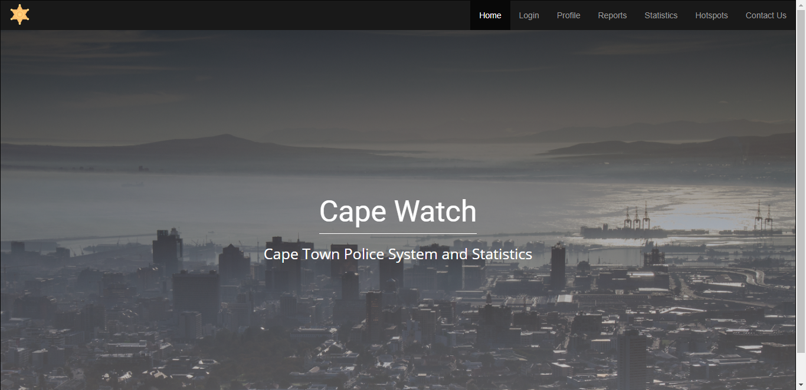

Figure 1: Home Page

### Login Page

Cape Watch Login page contains a field of “Email” and “Password” where registered users can input their details to log into the website. If an email or password has been entered into the field incorrectly, the website will not grant that user the ability to login.

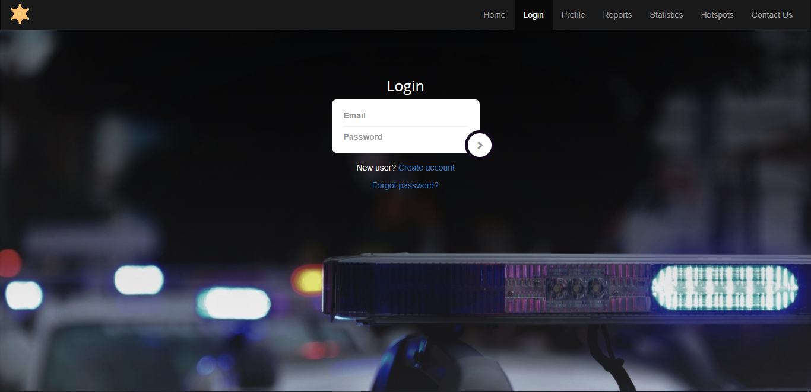

Figure 2: Login Page

New users has an option to create an account on the Cape Watch website. By clicking on the “Create account” option, the user will be redirected to a “Register” page where they will be required to fill in all the necessary information that the page asks the user for. The account will not be saved if a user has not filled in all the required fields.

The user will be required to click on the “Submit” button to save their account successfully.

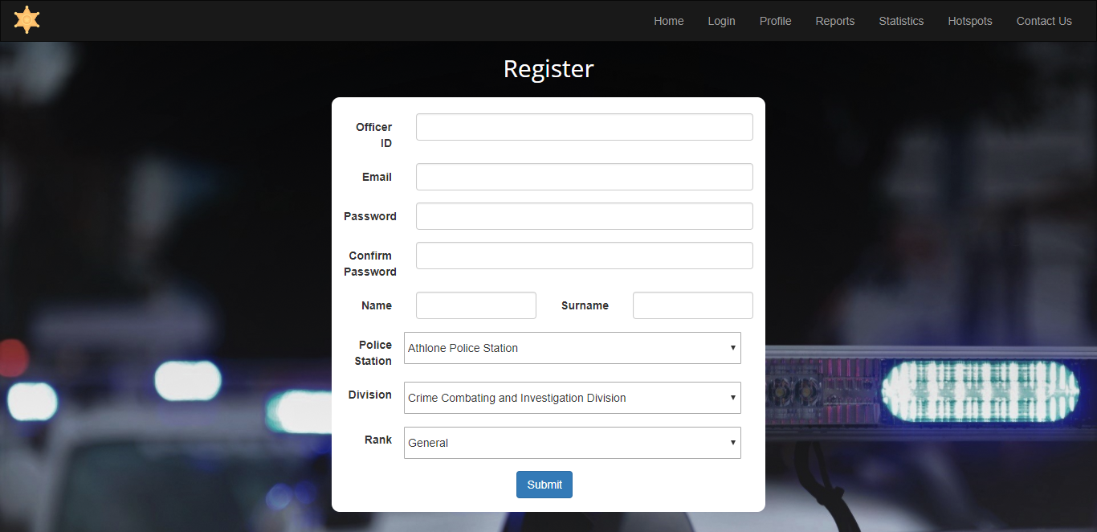

Figure 3: Register Page

Also, if a user has forgotten a password they have the option to click on the “Forgot password?” link which will redirected the user to a page where they can create a new password. //add image

Figure 4: Forgot Password

### Profile Page:

The profile page will only be available for authorised users.

This page contains a “Welcome Back” message with the users’ name attached to it. It also contains all the user information which is inputted by the user in the register page, which is displayed in a table format.

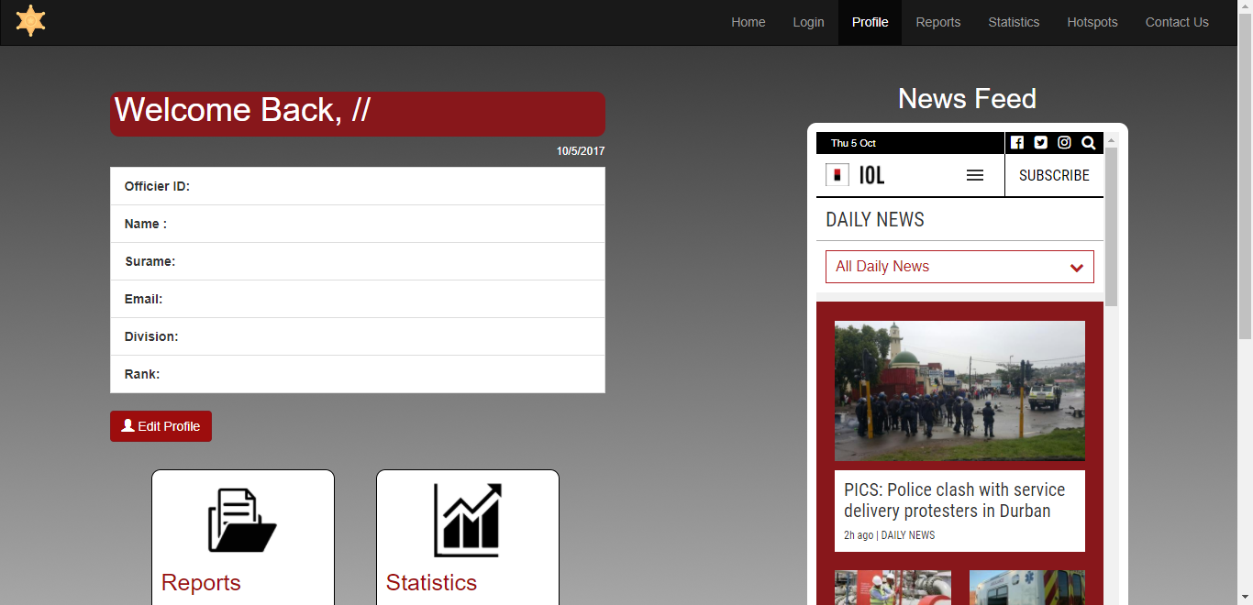

Figure 5: Top Half of Profile Page

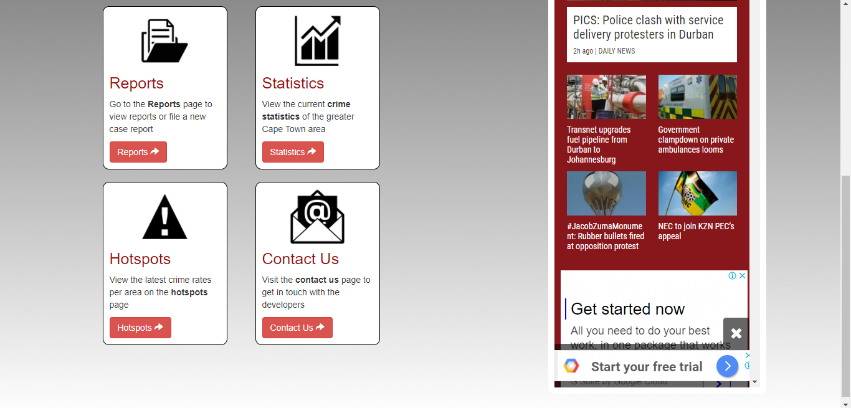

Figure 6: Bottom Half of Profile Page

On the right side of the page, users can view a general news feed which is frequently being updated by headline news. Users will have the ability to click on this newsfeed which will redirect them to the IOL Daily News page.

At the left bottom of the profile page is four blocks containing Reports, Statistics, Hotspots and Contact Us. In these blocks are buttons which will redirect the user to those corresponding pages once they have clicked on it.

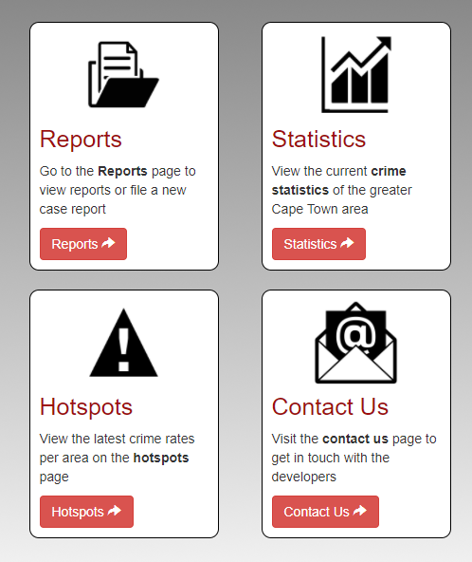

Figure 7: Profile Page Redirect Options

The profile page also contains an “Edit Profile” button which allows users the ability to edit their personal and professional information. This information will be saved and updated in the Cape Watch database. Users will need to fill in all required information before clicking the “Save changes” button.

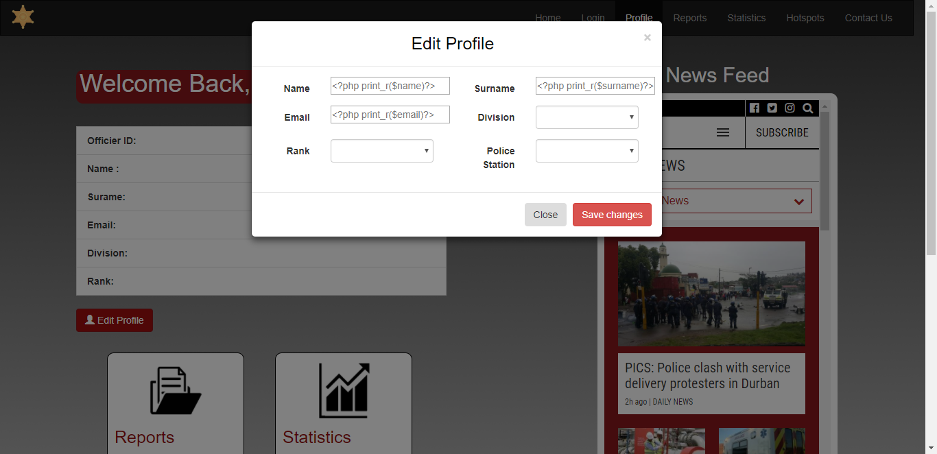

Figure 8: Edit Profile

### Reports Page:

The Reports page consists of a table with all the relevant information about the crime reports which has been submitted into the Cape Watch database.

A search bar has been placed on this page for a user to search a crime by its corresponding “CrimeID”, to make it easy and quick for the user to find what they are looking for.

Only authorised users will be allowed to access the Reports Page.

// add image

Figure 9: Reports Page

On the Reports Page, a user will have the ability to view all the details about a specific report. A user will not allowed to edit any information in the More Details information table.

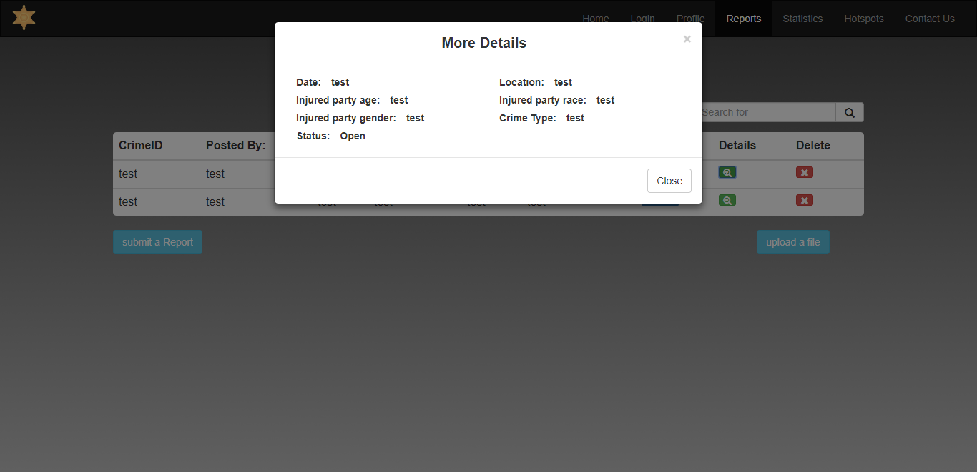

Figure 10: More Details

A user will have the ability to submit a new report on the Reports Page. All the information that is required needs to be entered into the appropriate field or the report will not be saved into the Cape Watch Database.

Once a report has been saved, it will appear in the Report table for all authorized users to view.

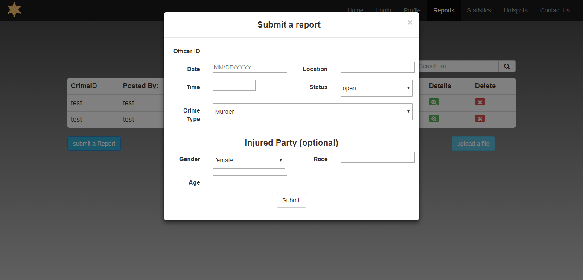

Figure 11: Submit a Report

### Statistics

### Hotspots

### Contact Us

The Contact Us page allows users the ability to contact the Xmeagol Company with any issues, concerns or requests.

A user will be required to fill in their email address and their name in the corresponding fields with their email message. Once a user has completed their message, they will be able to click on the “Send Message” button and their message will be successfully sent.

The Contact Us page also provides users with general information about the Xmeagol Company.

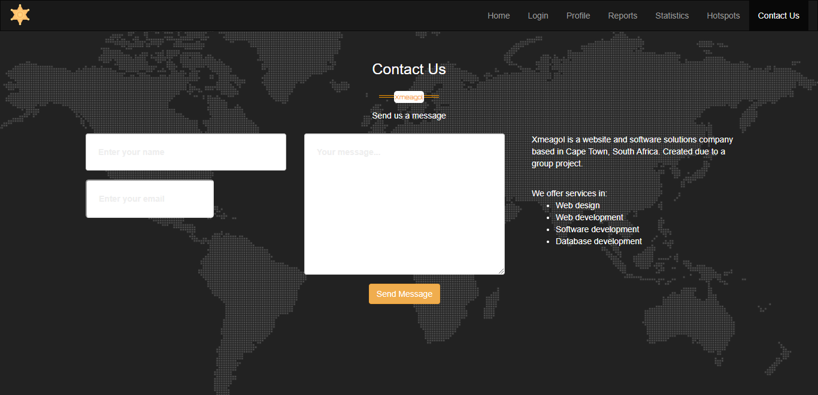

Figure ?: Contact Us